March - April 2019

Hi, we are in March already can you believe it? We are so pleased with the amount of Small Wonders attending each week recently. Thank you for your commitment to coming along as much as possible. This really honours our amazing team of dedicated volunteers who are committed to serving you each week. Thank you all.

Funding
We are so excited that we have recently had 2 funding bids granted. We have received £955 from Chris Westwood Charity & £312.00 from James Beattie Charitable Trust. Watch out for new equipment to play with very soon!!

We urgently need more bakers
Would you join our baking rota baking either 12 or 24 cakes either weekly, fortnightly or monthly? Cake is a big part of Small Wonders which we all look forward to each week. If you would like to be involved please speak to a member of the Small Wonders team. We would be very grateful.

We really need some more volunteers to join our incredible team.
Do you know anyone who has some free time when they are childfree, either
Thursday afternoons 1.30 – 3pm to set up all the toys or anytime on Fridays?
Maybe a Small Wonder Grandparent or a neighbour or friend? We would
love to have more people on our team. There are lots of different jobs to be involved with, serving refreshments, washing up, playing, holding babies, chatting with parents/ carers, on the welcome desk, tidying up, setting up for parties, singing etc.. Behind the scenes jobs too! We volunteer because…
“I think my world would be poorer without my dose of Small Wonders each week, and I think I might age faster without it!”
“I started volunteering with Small Wonders because it was such an important part of my life with two small children. I wanted to 'pay it back' and ensure this continued for others. “
“Small Wonders is such a lovely family, always friendly”
“For anyone who is lonely or not confident in a team setting, it's a brilliant opportunity to grow. You will be loved, valued and encouraged.”
“I volunteer because it’s an opportunity for me to use my creative gifting with real impact and purpose. I’m not there in a Friday but know I can have a little bit of impact in people lives.”

The Small Wonders Freebies! Facebook Page has really taken off, we are delighted! A couple of things to remember please clearly name any items you are bringing in to give away & ensure that if you come to the afternoon session & you are giving to someone in the morning session that they will need to arrange collection as we are unable to store any items between weeks. Please be mindful if you have had loads of freebies to make sure others get a chance at getting some freebies too! Lastly remember to collect your freebies before you leave. If you don’t know what any of this means you are missing out!! Search for Small Wonders Freebies! On Facebook & request to join our closed group you can get yourself some freebies & pass on some unwanted childrens items to other Small Wonder parents/ carers who could use them

Parking
You will have received an email about this so please make sure you have read &
understood it.
Many people park on the roads around LifeSpring centre which is free for 2 hours. Many
of you park in the council run carpark at the end of Clifton street which is £1.20 for up to
4 hours. These are still the same, nothing has changed with either of these.
We also have an agreement with The Welsh Church to use part of their car park for £1 during a Small Wonders session if you cannot find parking anywhere else.
This is a separate carpark to the Council run one!

We have recently been informed that we can only use a part of the Welsh Church Car park for Small Wonders. We really need ALL to abide to what we have been asked with regards to this carpark to ensure we can continue using it each week. It is accessible via Lord Street only.
The parking we have been allocated is against the row of conifer trees (grass area only) all along this side is fine for Small Wonders. PLEASE DO NOT PARK ALONG THE FENCE (tarmac area) as this area is allocated by the Welsh Church for permit holders.

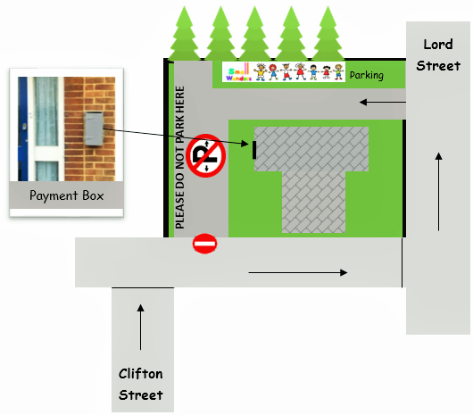
Cameras are being installed soon and in the meantime registration numbers
will be taken. A payment box is being installed on the wall outside, please
ensure you place £1 in this box each week and place your NEW Small
Wonders Token on your dashboard to ensure the Caretaker knows that you
are from Small Wonders.

Please collect a NEW CAR PARK TOKEN from the information desk at Small Wonders.
Please let us know if you have any questions.

Dates for your diary…..
We will be celebrating Africa Day on Friday 17th May.
We will have our very own Small Wonder jungle to play in & we are hoping to be
joined by some African singers! We will be raising money for LifeSpring’s
Children’s home in Mozambique. We will be selling some excellent condition pre-
loved toys as well so please bring some extra pennies. You are welcome to dress your Small Wonders up as a jungle animal or in traditional African dress.

Small Wonders Trip
Our annual day out will be on Friday 7th June when we will be going to
Lower Drayton Farm in Penkridge for the day. Small Wonders will have
the whole farm to ourselves! The cost will be £3 per adult & £5 per child
with under 2’s being free. This is a generous discount from the farm
especially for us. Look out for more details on what’s included in the trip,
what to bring & how to sign up & pay after Easter.

Our last Small Wonders of this term is Friday 12th April. We will be back after the Easter holidays on Friday 3rd May.

Helen, Ursula & all the Small Wonders team x

If you would like to contact us you can:
Email: info@oursmallwonders.com Text: 07921103866 Website: www.oursmallwonders.com
Private Message: Facebook.com/SmallWondersStayandPlay

